Resource Manager
-Private-endpoint with ORM Stack

Contents

1. Introduction 3
2. Workflow diagram to deploy the stack 3
3. Create Stack 4
4. Upload the Artifacts 5
5. Plan the Job 6
6. Apply the Job 7
7. Verify in the Console 8
8. Destroy the stack 9

Introduction

A private endpoint is a set of network information that allows Resource Manager to access nonpublic cloud resources. A private endpoint is a private IP address within your VCN that you can use to access a given service within OCI. The service sets up the private endpoint in a subnet of your choice within the VCN. You can think of the private endpoint as just another VNIC in your VCN.

Workflow diagram to deploy the stack
Below diagram shows how the Terraform Artifact are applied in the OCI. While creating a ORM stack, using terraform deliverables Init, Plan and Apply is the flow to provision the resource in the OCI. We can have the deliverables in any of below.
- GitLab/GitHub Repo
- Bitbucket
- Can be in folder/.zip in the local disk
- Object Storage Bucket
- Can be in compartment
- Oracle provided Template


Create Stack

Go to OCI Console Developer Services Resource Manager Stacks select the compartment Create Stack

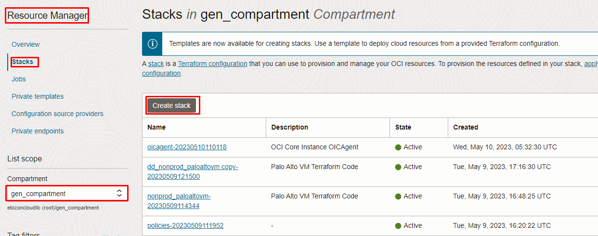

Upload the Artifacts

My Configuration Folder Browse

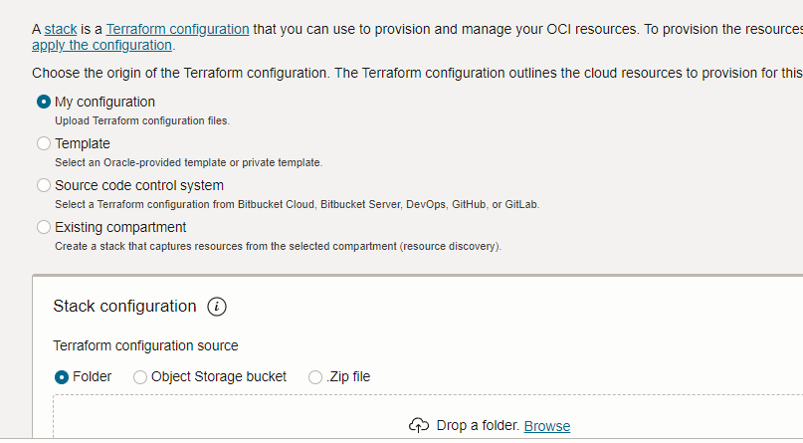

Review the values in the Configure Variables page and click Next

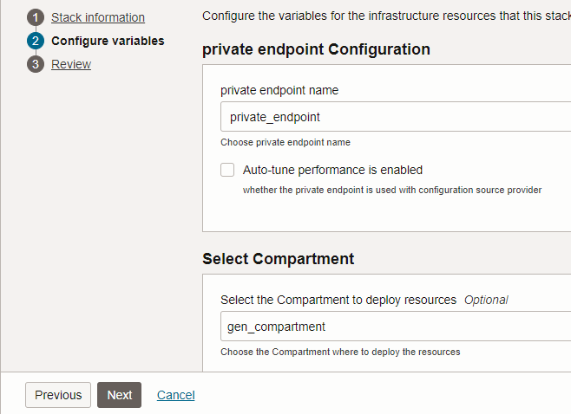

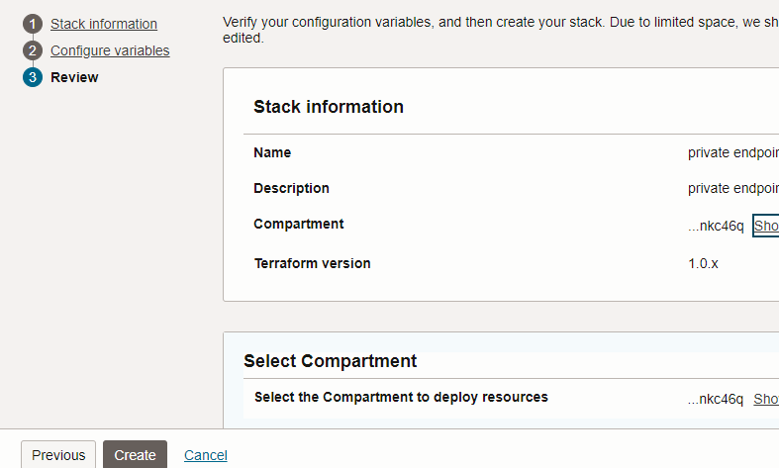
Review and click create

Plan the Job

Click the “Plan”

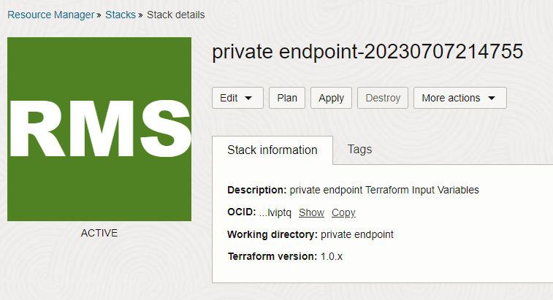

Verify the Plan is successful.

Apply the Job
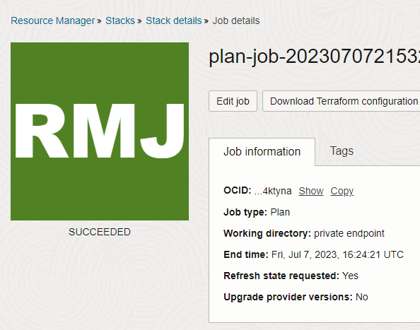
Once the “plan” is success, now click “Apply”

Verify the Apply is successful.
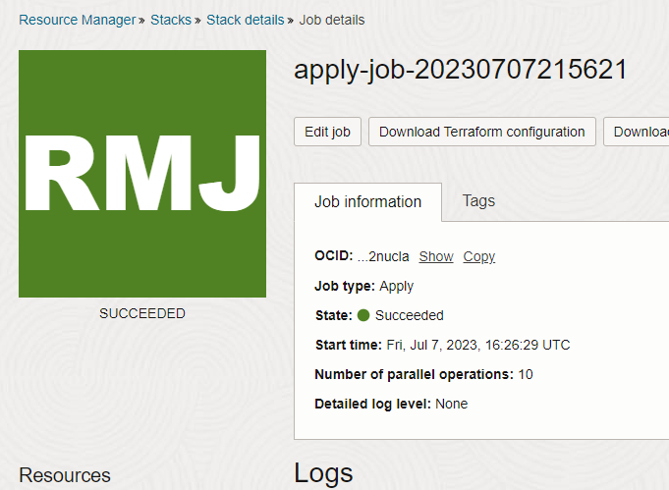

Verify in the Console

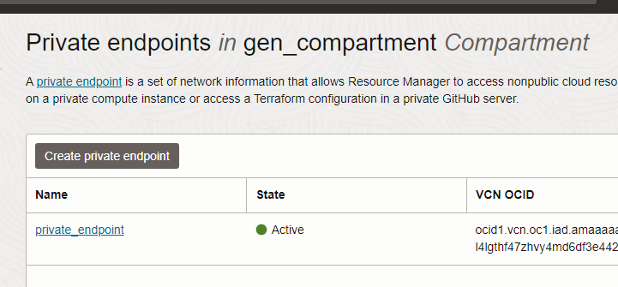
Go to OCI Console Developer services private endpoint

Destroy the stack
Create a destroy job in Resource Manager to release resources associated with a stack and clean up the tenancy. Once destroyed data cannot be recovered from resources

# END #

